H.T No
Regulations:
A22

Sreenidhi Institute of Science and Technology
(An Autonomous Institution)
Code No: 9EC01 Date: 23-Aug-2023 (FN)

B.Tech I-Year II- Semester External Examination, Aug/Sept-2023 (Regular)
DATA STRUCTURES (Common to All)

Time: 3 Hours Max.Marks:60

Note: a) No additional answer sheets will be provided.
b) All sub-parts of a question must be answered at one place only, otherwise it will not be valued.
c) Missing data can be assumed suitably.
Bloom's Cognitive Levels of Learning (BCLL)

Remember | L1 | Apply | L3 | Evaluate | L5
Understand | L2 | Analyze | L4 | Create | L6

Part - A Max.Marks: 6x2=12

Answer all QUESTIONS, EACH QUESTION CARRIES 2 MARKS.

 |  | BCLL | CO(s) | Marks
1 | List some common data structures. | L1 | CO1 | [2M]
2 | Differentiate between stack and queue. | L4 | CO2 | [2M]
3 | Give advantages of linked list over arrays. | L2 | CO3 | [2M]
4 | Draw a binary tree with seven nodes and three leaves. | L1 | CO4 | [2M]
5 | Define weighted and directed graph. | L1 | CO5 | [2M]
6 | What are the best and worst case time complexities of merge sort? | L2 | CO6 | [2M]

Part – B Max.Marks: 6x8=48
ANSWER ALL QUESTIONS. EACH QUESTION CARRIES 8 MARKS.

 |  |  | BCLL | CO(s) | Marks
7. | a) | Define a structure. Develop a C program to implement student structure (Roll No, Name, Marks). | L6 | CO1 | [8M]
 |  | OR
 | b) | Explain about various Dynamic memory allocation functions with suitable examples. | L2 | CO1 | [8M]
8. | a) | Utilize stack, convert the following infix to postfix a+b*c-(d/e)^f*h | L4 | CO2 | [8M]
 |  | OR
 | b) | Write about stack ADT implementation using arrays. | L1 | CO2 | [8M]
9. | a) | Write pseudo-code for delete specific element in singly linked list. | L1 | CO3 | [8M]
 |  | OR
 | b) | Difference between single and double linked lists? Write the disadvantages of linked lists. | L4 | CO3 | [8M]
10. | a) | Derive post-order and pre - order travel using stack for the given binary tree  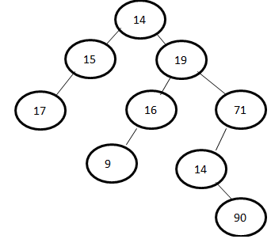 | L3 | CO4 | [8M]
 |  | OR
 | b) | Construct binary search tree for the nodes  12, 3, 34, 56, 6, 16, 36, 39, 84, 10, 58, 83, 87 | L6 | CO4 | [8M]
11. | a) | Construct max heap for the following elements: 40, 80 , 30 , 20 ,10 ,40, 30, 60 ,100 ,70 ,160 ,50 , 130, 110, 120. | L3 | CO5 | [8M]
 |  | OR
 | b) | Derive DFS for the given graph using necessary data structure.  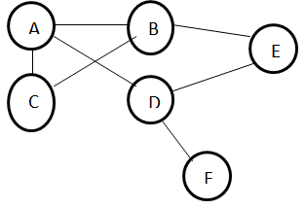 | L3 | CO5 | [8M]
12. | a) | Build Binary Search Algorithm and Develop Binary search program using recursion. | L6 | CO6 | [8M]
 |  | OR
 | b) | Rearrange following numbers using merge sort  14, 19, 6, 5, 50, 18, 26, 42, 1, 9, 12 | L6 | CO6 | [8M]

-- 00 -- 00 –

